University of Dhaka (DU) Faculty of Engineering and Technology
Department of Electrical and Electronic Engineering


0613-CSE-1206: Computer Programming Laboratory

Lab Project (Group - 10)
Title: Design and Implementation of a 2D Beat ‘em Up Fighting Game Using Object Oriented Programming, OpenGL Rendering and Multimedia Integration

Submitted By
Group Members:
- SH-168-001, Reg. No. 2024113223, Name: Irtifa Rahman Khan
- SH-168-019, Reg. No. 2024113241, Name: Hossain Mohammad Sabbir
- AE-168-032, Reg. No. 2024713254, Name: Mashruk Bin Islam
- FH-168-038, Reg. No. 2024013260, Name: Mohibur Rahman
- AE-168-039, Reg. No. 2024913261, Name: Nafeem Bin Huda

Submitted To

Dr. Khaleda Ali, Associate Professor, Dept. of EEE, DU. Md. Nizam Uddin Tanim, Lecturer, Dept. of EEE, DU.


University of Dhaka

Department of Electrical and Electronic Engineering
Course Code: 0613-CSE-1206 Admission Session: 2024-25 Course Title: Computer Programming Laboratory Assessment: Final Project Total Marks: 20
Instructor: Dr. Khaleda Ali, Md. Nizam Uddin Due Date: June 21, 2026 Tanim
Lab Group : 10
Title: Design and Implementation of a 2D Beat 'Em Up Fighting Game Using Object-Oriented Programming, OpenGL Rendering, and Multimedia Integration
Problem Statement: Traditional game development requires the integration of multiple complex systems including graphics rendering, animation management, collision detection, audio processing, and player interaction mechanics. Developing these systems independently often results in repetitive code structures, poor scalability, and difficulties in maintaining game performance and responsiveness. Furthermore, creating an engaging gaming experience demands efficient management of sprite animations, texture rendering, combat mechanics, and immersive audiovisual feedback.
To address these challenges, this project introduces a custom-built 2D Beat 'Em Up fighting game developed using Object-Oriented Programming principles and modern graphics programming techniques. The system utilizes OpenGL for real-time rendering, GLFW for window and input management, GLAD for OpenGL function loading, and STB libraries for texture processing. Character sprites and animation sheets are designed using Piskel and integrated into the game engine through an efficient sprite-based animation framework.
The game implements modular character classes, enemy AI behaviors, collision detection systems, health management mechanics, and frame-based animation controllers to create dynamic combat interactions. Additionally, texture mapping and audio integration are employed to provide an immersive gameplay experience. The resulting application demonstrates the practical application of intermediate C/C++ programming concepts, software engineering principles, and computer graphics techniques in the development of an interactive entertainment system.


Data: Consider the folder “Data I” provided along with this assignment.
 | COs | POs | *DTLs
Use intermediate C/C++ programming concepts, Object-Oriented Programming, and graphics libraries to develop a 2D Beat ’Em Up fighting game with real-time rendering, animation, collision detection, and combat mechanics. | CO3 | PO5 | C6
Organize the project technical report and presentation effectively to communicate the game architecture, rendering pipeline, animation framework, and gameplay mechanics. | CO3 | PO10 | C6
Compute project development resources, implementation schedules, asset creation requirements, and estimated deployment costs to support  successful game development and testing. | CO3 | PO11 | C6
Describe the self-directed learning process, graphics programming resources utilized, and iterative optimization improvements made to  rendering performance, animation systems, and gameplay mechanics. | CO2 | PO12 | C5

Title:

Design and Implementation of a 2D Beat ‘em Up Fighting Game Using Object Oriented Programming, OpenGL Rendering and Multimedia Integration.

Objectives:

- To design and develop a 2D beat ‘em up fighting game using Object-Oriented Programming principles in C/C++
- To implement real-time graphics rendering, sprite-based animation and audio using OpenGL, GLFW, GLAD, STB, Miniaudio libraries
- To develop collision detection, combat mechanics, health management and enemy AI behavior for interactive gameplay
- To integrate texture mapping and audio feedback in order to create and immersive gaming experience

Problem Statement:

Traditional game development requires the integration of multiple complex systems including graphics rendering, animation management, collision detection, audio processing, and player interaction mechanics. Developing these systems independently often results in repetitive code structures, poor scalability, and difficulties in maintaining game performance and responsiveness. Furthermore, creating an engaging gaming experience demands efficient management of sprite animations, texture rendering, combat mechanics, and immersive audiovisual feedback.
To address these challenges, this project introduces a custom-built 2D Beat 'Em Up fighting game developed using Object-Oriented Programming principles and modern graphics programming techniques. The system utilizes OpenGL for real-time rendering, GLFW for window and input management, GLAD for OpenGL function loading, and STB libraries for texture processing. Character sprites and animation sheets are designed using Piskel and integrated into the game engine through an efficient sprite-based animation framework. The game implements modular character classes, enemy AI behaviors, collision detection systems, health management mechanics, and frame-based animation controllers to create dynamic combat interactions.

Sample Run:
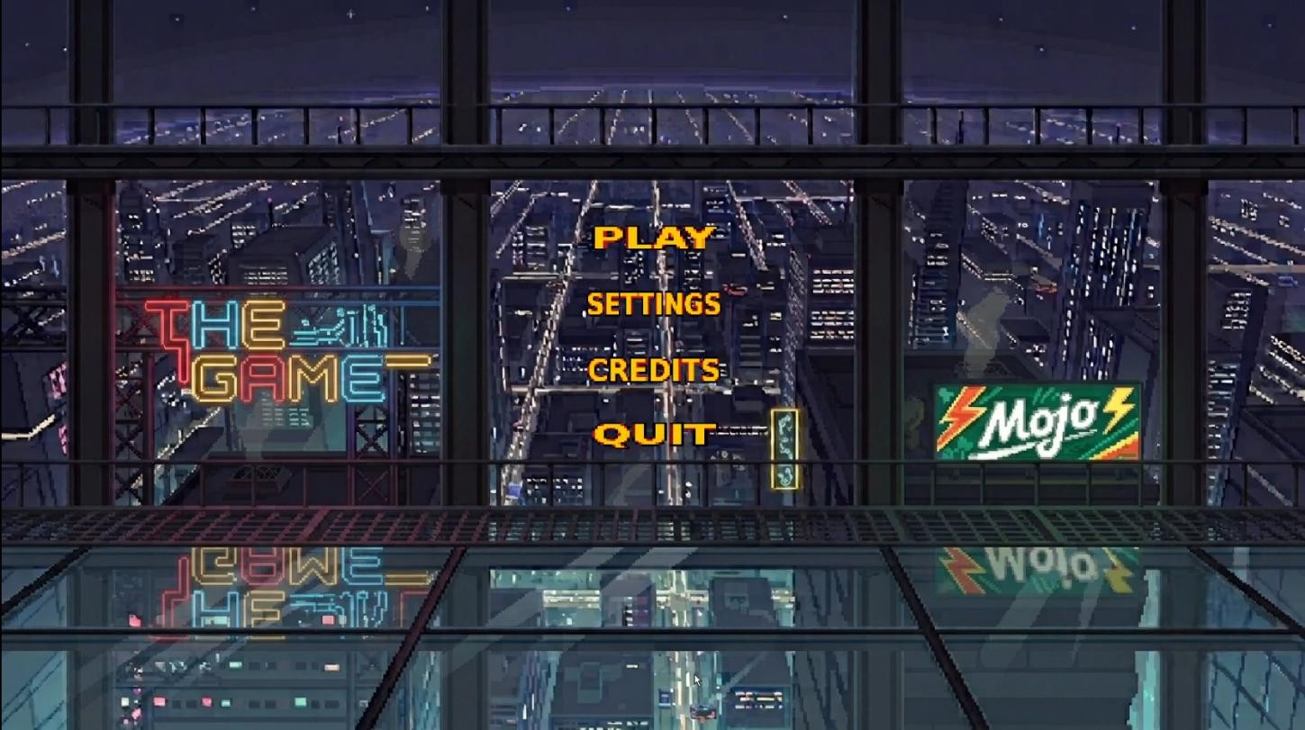
Fig - 1: When game is started

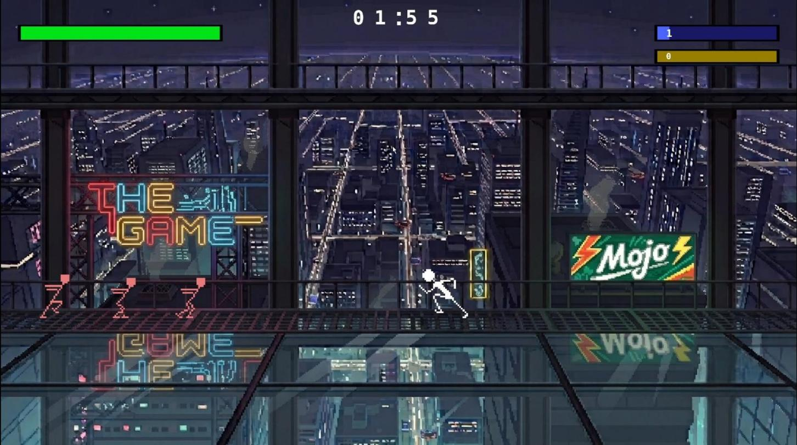
Fig - 2: Player running towards enemy and vice versa

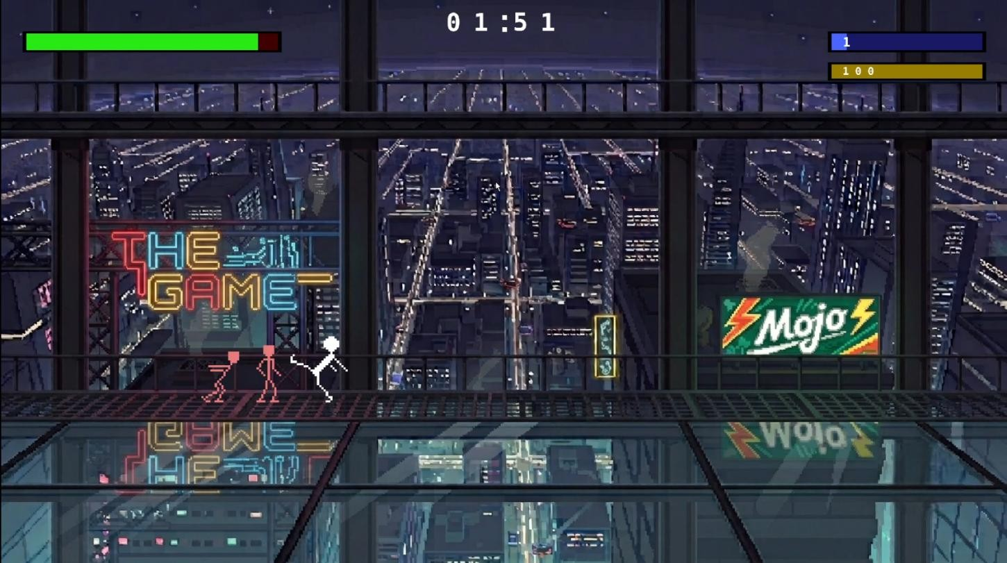
Fig - 3: Player attacking enemy

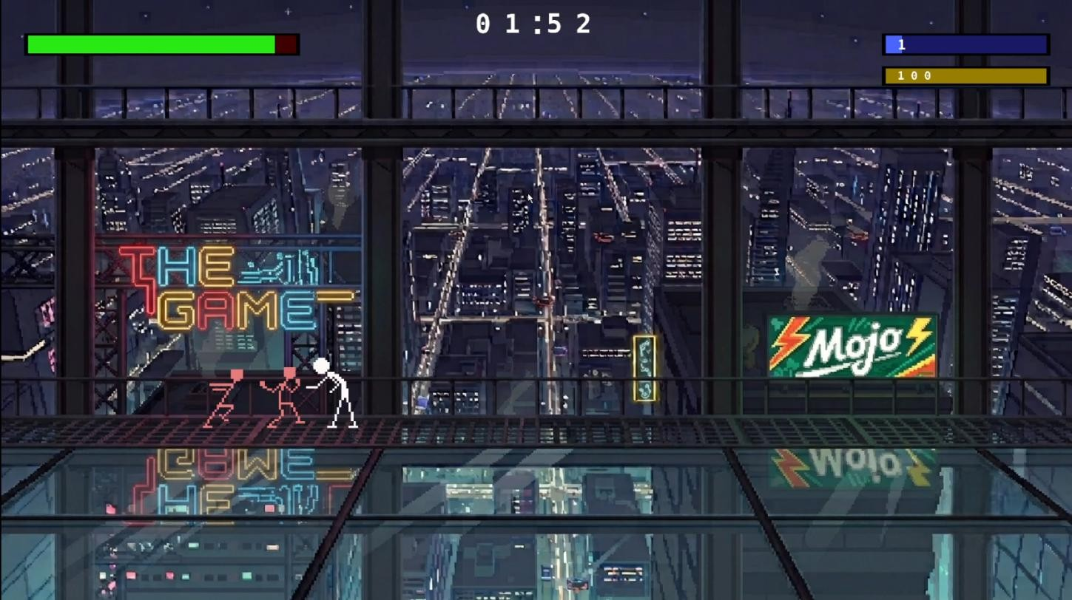
Fig - 4: Player being hit

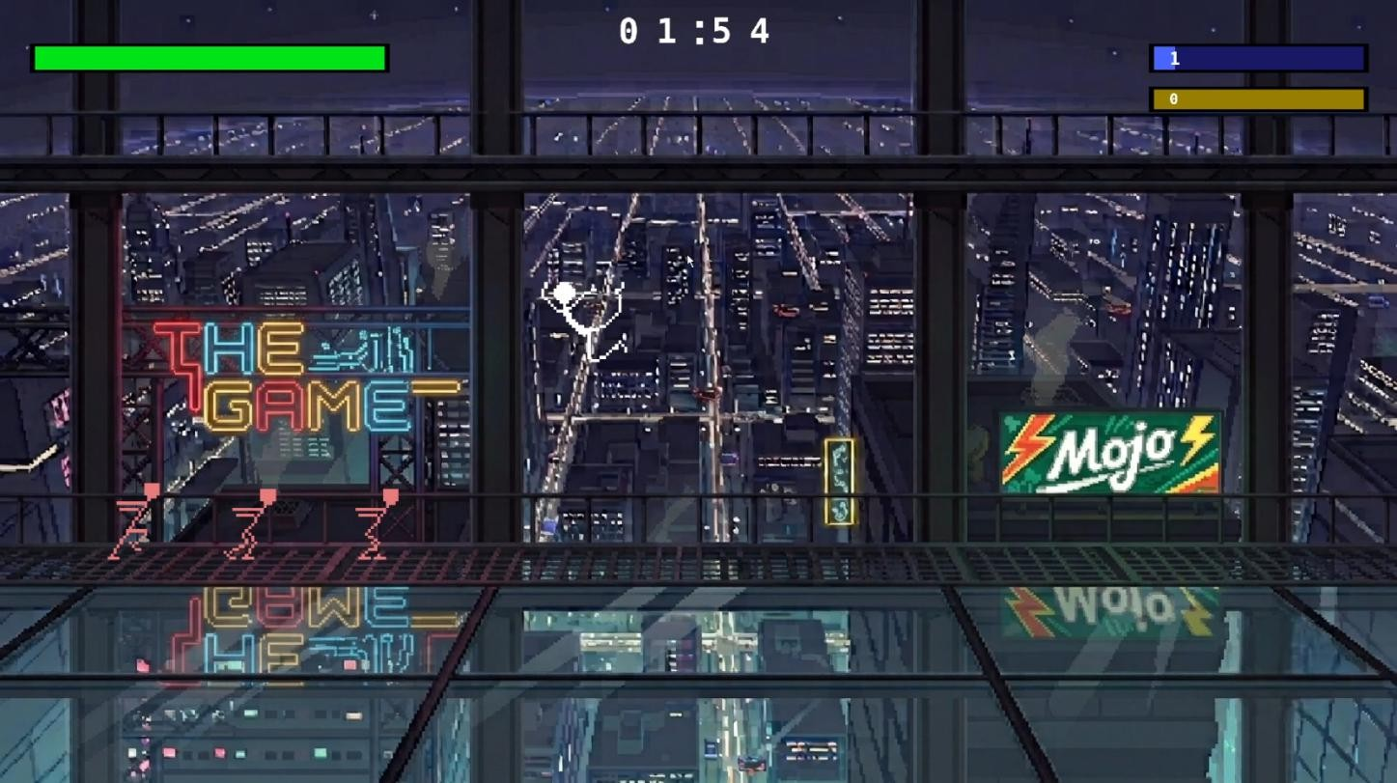
Fig - 5: Player jumping

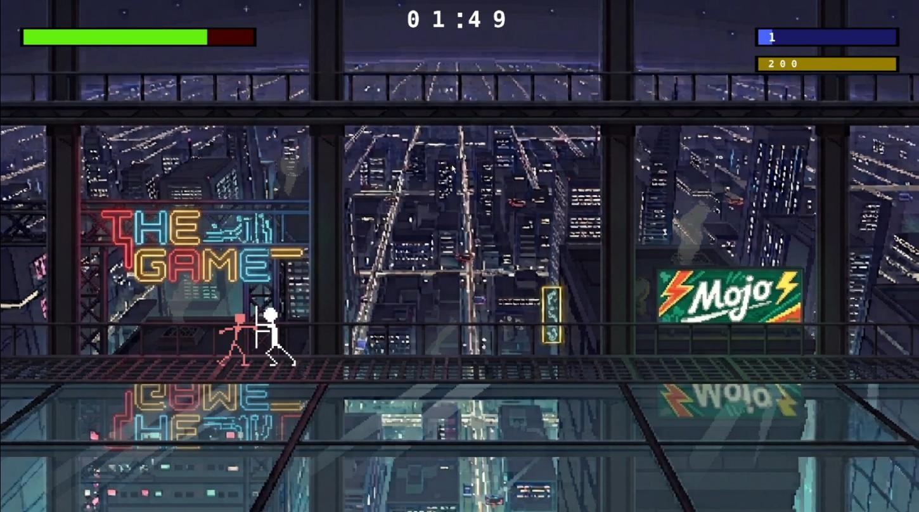
Fig - 6: Player blocking

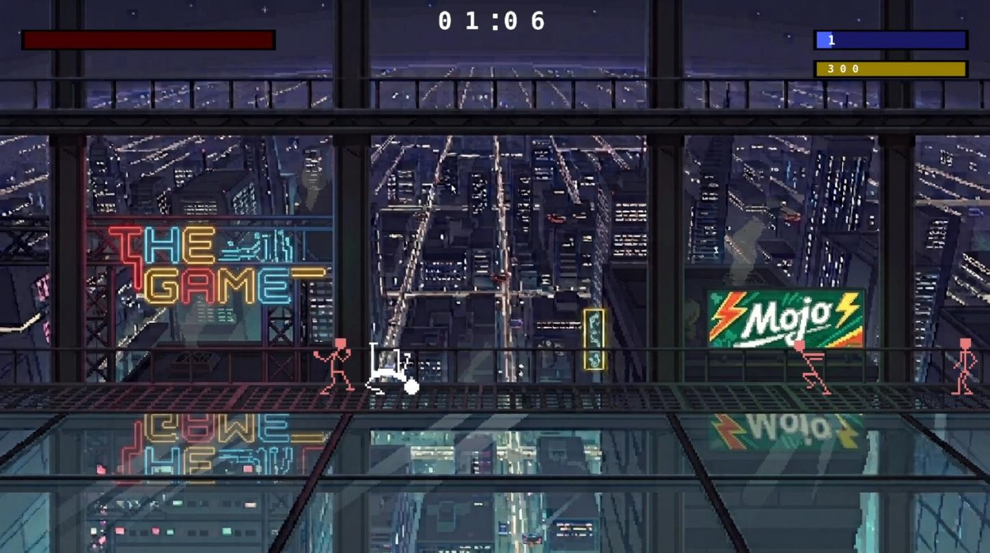
Fig - 7: Player knocked out

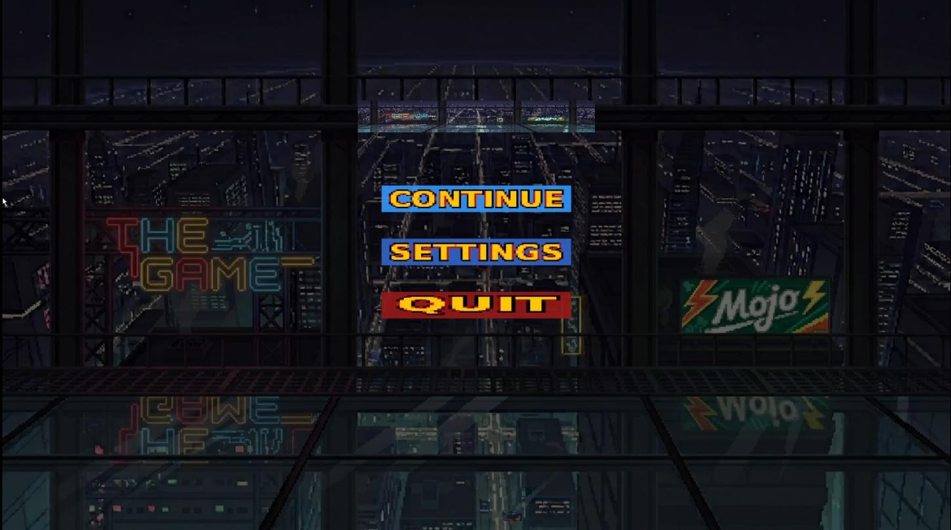
Fig - 8: Pause screen

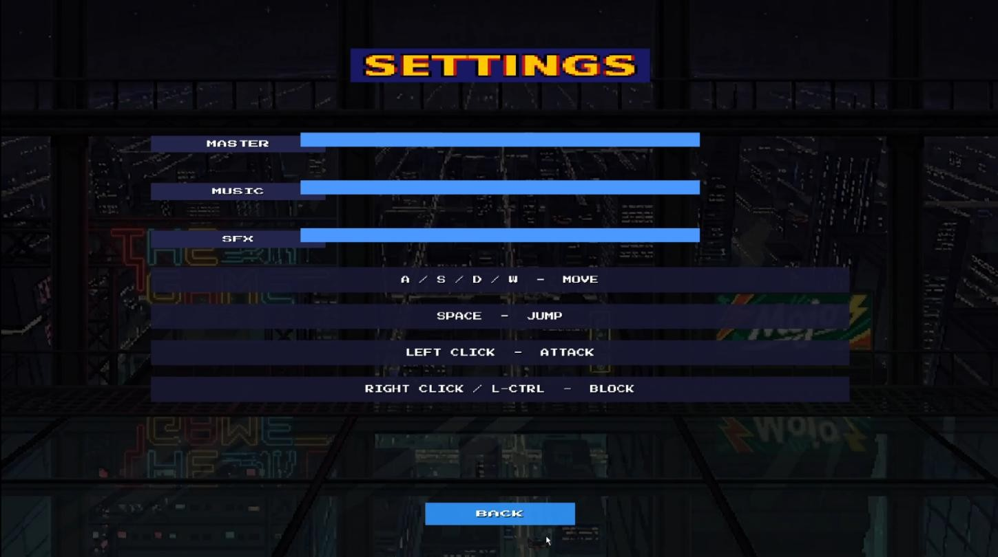
Fig - 9: Settings

Discussion:
This project is a 2D Beat 'Em Up fighting game developed using C/C++ with Object-Oriented Programming principles and the OpenGL graphics pipeline. Its main purpose is to demonstrate the integration of real-time rendering, sprite animation, collision detection, and combat mechanics within a single interactive application, while keeping the codebase modular and maintainable.
The system architecture is organized around a set of core classes. A base Character class encapsulates common attributes such as position, health, movement speed, and animation state, from which Player and Enemy classes are derived. This use of inheritance and polymorphism allows shared behavior, such as sprite rendering and health management, to be reused while allowing player-controlled and AI-controlled characters to override input handling and decision-making logic independently. A separate Animation class manages frame sequences, frame timing, and sprite-sheet coordinates, allowing each character to cycle through idle, walking, attacking, and hit-reaction animations smoothly.
The rendering pipeline is built on OpenGL, with GLFW used to create the application window, manage the rendering context, and capture keyboard input. GLAD is used to load OpenGL function pointers at runtime, ensuring compatibility across different graphics drivers. Textures for

character sprites and backgrounds, exported as sprite sheets from Piskel, are loaded using the STB image library and mapped onto textured quads. Each animation frame corresponds to a specific region of the sprite sheet, selected using texture coordinate offsets that are updated as the animation progresses.
Collision detection between characters is implemented using axis-aligned bounding boxes (AABB) attached to each character's current sprite frame. During every update cycle, the game checks for overlap between the player's attack hitbox and the enemy's hurtbox, and vice versa, to determine whether an attack lands. When a collision is detected during an active attack animation frame, the target's health is reduced according to the attack's damage value, and a hit-reaction animation and corresponding sound effect are triggered.
Enemy behavior is governed by a simple state-based AI controller, which transitions between idle, pursue, attack, and retreat states depending on the enemy's distance from the player and its current health. This allows enemies to approach the player, initiate attacks within range, and react to being hit, providing a basic but responsive combat opponent without requiring complex pathfinding.
Health management is handled through a health-points system for both the player and enemy characters, visually represented using on-screen health bars rendered as scaled rectangles that update each frame in proportion to remaining health. When a character's health reaches zero, its state transitions to a defeated animation, and the game evaluates the match outcome, displaying a victory or game-over screen accordingly.
Audio integration provides immediate feedback for key gameplay events, including attack sounds, hit impacts, and background music, enhancing the overall immersion of the game. Input handling is managed through GLFW's keyboard callback functions, mapping specific keys to movement, attacks, and blocking actions, with input state checked once per frame within the main game loop.
The main game loop follows the standard structure of processing input, updating game state (including animation frames, physics, AI decisions, and collision checks), and rendering the current frame, repeated continuously until the window is closed or the match concludes. This loop-based structure, combined with delta-time calculations, ensures that animation speed and gameplay logic remain consistent regardless of variations in frame rate.

Overall, the project demonstrates the practical application of Object-Oriented Programming, real-time graphics rendering, and multimedia integration in building an interactive 2D fighting game, while highlighting core game-development concepts such as sprite animation, collision detection, and state-based AI design.

References:
- J. de Vries, "Learn OpenGL: Graphics Programming," learnopengl.com, 2020.

- GLFW Documentation, "GLFW: An OpenGL, OpenGL ES and Vulkan Library," glfw.org.

- S. Barrett, "stb_image.h: Single-file public domain image loader," github.com/nothings/stb.

- K. N. King, "Structures, Unions and Enumerations," in C Programming: A Modern Approach, 2nd Edition, New York, USA: W. W. Norton & Company, 2008, ch. 4, pp. 377-386.

